AP Statistics 7.3 The Jennifer/John study Name: ____________________________________

<https://www.pnas.org/content/109/41/16474>

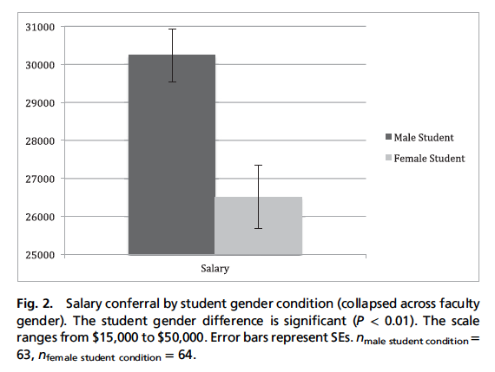

Science faculty were all given the same resume for a lab manager position. Half the resumes had the name Jennifer, and the other had the name John. Was the mean starting salary offered Jennifer, $26,508, significantly lower than that of the $30,238 offered to John? There were 63 John resumes and 64 Jennifer resumes sent out. SD for John was approx. 5,000 and for Jennifer 7,000.

a. What would be the reason or the difference between doing a hypothesis test versus a confidence interval here?

b. Construct a 95% CI for the ________________________________________________________________ .   
 Fill in blank with words. Now finish the confidence interval procedure with the CCCC steps.

c. Now, say know specifically how much evidence we have *against* the null hypothesis H0: ___________ , we will carry out a hypothesis procedure. Use ICCCC.

d. Interpret the p-value in context.

e. Can we tell from this test which faculty are discriminating? That is, can we determine that the faculty that offered low salary to Jennifer must be biased?

f. Why can we not tell which faculty were discriminating?

g. Can we redo this same experiment as a matched pairs experiment? If so, how?

h. Why can we not do this as a matched pairs experiment?